Multiple Cranial Nerve Palsy (MCNP) in Cerebral Sinus Vein Thrombosis (CSVT) due to Bilateral Septic Cavernous Sinus Granulomatous Abscess and Multiple Sinusitis: A Case Report
M. Ikhlas Muttaqin Aditiarman^{1*}, I Wayan Tunjung², Dhesty Fadhilah Faatin³, M. Sofyan Faridi⁴
¹Emergency Departement, H. Moh. Ruslan General Hospital, Mataram City, West Nusa Tenggara, Indonesia
²Neurology Departement, H. Moh. Ruslan General Hospital, Mataram City, West Nusa Tenggara, Indonesia
³Emergency Department, North Lombok General Hospital, North Lombok, West Nusa Tenggara, Indonesia
⁴Faculty of Medicine, Islamic University of Al-Azhar, Mataram, West Nusa Tenggara, Indonesia

DOI: https://doi.org/10.29303/dbq0zm27

Article Info |  |  | Abstract: Case reports about cavernous sinus venous thrombosis (CSVT) with ophtalmoplegia are relatively rare caused by a long-standing dental infection complicated by a history of long-term smoking, leading to granulomatous abscesses and multiple sinusitis. A 48-year-old man admitted to the Emergency Department presenting of an inability to lift his left eyelid and to move his eyeball in any direction for the past 3 days, the symptoms were experienced suddenly. Multiple cranial nerves palsy (MCNP) or ophtalmoplegia in CSVT is a neurological disorder involving more than two non-homologous cranial nerves simultaneously. CSVT in this case occurs as a result of inflammation in response to granulomatous abscess of the cavernous sinus and multiple sinusitis due to a longterm untreated history of dental infection with long history of smoking. Clinical accompanying was progressive headache, ophtalgia, ptosis and proptosis. This case report highlights the importance of neuroimaging examinations, particularly CT scans, MRI, and MRA of the head, as the primary standard for establishing a diagnosis of CSVT, thereby enabling appropriate evaluation therapy and substantially determining a favorable prognosis.
Received | : | 02-03-2026
Revised | : | 11-03-2026
Accepted | : | 20-04-2026
 |  |  | Keywords: cavernous sinus venous thrombosis, multiple cranial nerves palsy, granulomatous abscess, multiple Sinusitis, ophtalmoplegia.
Citation: Aditiarman, M. I. M., Faridi, S. F., Tunjung, I. W., & Faatin, D. F. (2026). Multiple Cranial Nerve Palsy (MCNP) in Cerebral Sinus Vein Thrombosis (CSVT) due to Bilateral Septic Cavernous Sinus Granulomatous Abscess and Multiple Sinusitis: A Case Report. Lombok Medical Journal, 5 (2), 60-68. Doi: https://doi.org/10.29303/dd3y8n39

Introduction

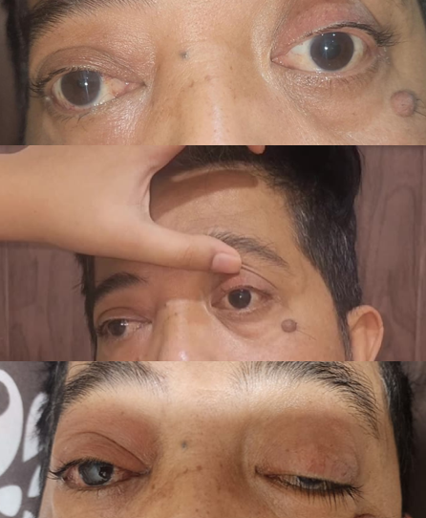
Cavernous sinus vein thrombosis (CSVT) is a rare condition in the form of thromboembolism in the veins or venous infarction characterized by obstruction of the cavernous sinus either cortically or cerebrally, which causes symptoms similar to a stroke. Cavernous sinus syndrome is the most common anatomical syndrome with a generally acute clinical course. In a study conducted by Daniele et al., the recurrence rate of CSVT was 25.7% in men and 11.7% in women. Among those who suffered a stroke, CSVT only represented 0.5% - 3% of all stroke cases. This case report describes a chronic odontogenic infection with a long history of smoking, complicated by a granulomatous cavernous sinus abscess and multiple sinusitis, resulting in CSVT or venous infarction with neurological deficits including multiple cranial nerve palsies (MCNP) or ophthalmoplegia, with associated clinical features including eye pain, diplopia, ptosis, proptosis, and pain radiating to progressive headache. (Saposnik et al., 2024; Ee See Ong et al., 2023; Ciarambino et al., 2023; Cetin et al., 2021; Anton-Vazquez et al., 2020)

Case Presentation

A 48-year-old man, Mr. A, admitted to the Emergency Department of Mataram City General Hospital on July 29, 2025. One week prior, the patient complained of severe and progressive headache, had taken painkillers but the headache persisted. Three days before admission, he experienced sudden inability to lift his left eyelid and could not move his eyeball in any direction. The same complaint was noted in the right eyelid, which he could not lift, although he was still able to move the eyeball in all directions. Other associated complaints included double vision (diplopia), blurred vision especially in the left eye, sensitivity to light (photophobia), eye pain when pressed (ophthalalgia), protrusion of the eyeball (proptosis), and eyelid weakness (ptosis), all of which were more pronounced in the left eye. The patient has a history of untreated dental infection since childhood. The complaints were also accompanied by infrequent nausea and vomiting, and intermittent fever.
Other accompanying complaints such as neurological deficits in the hands and feet are not present, speech disorders are not present, higher function disturbances are not present, complaints of defecation and urination are denied. History of head trauma or impact is denied. History of high blood pressure, diabetes, high cholesterol, previous stroke is denied, history of heart disease is denied. Family history of disease is denied. The patient has a history of smoking since junior high school.

Figure 1. Clinical description of patients with cavernous sinus vein thrombosis (CSVT) and 2nd, 3rd, 4th, and 6th of multiple cranial nerve/ophtalmoplegia

The patient was treated for 3 weeks and given antipyretic and analgesic management, namely Peinloss at a dose of 3x400 mg by injection, given a gastric acid reducer, namely pantoprazole at a dose of 1x40 mg by injection, given antibiotics as anti-inflammatory treatment, namely ceftriaxone at a dose of 2x2 g IV, and given the steroid dexamethasone at a dose of 3x10 mg IV as anti-inflammatory. Administration of the anticoagulant heparin was also given to the patient. The patient was treated for 3 weeks with monitoring of clinical progress and the therapy provided, and a significant improvement was observed, although it had not yet reached the maximum treatment.
Physical examination found the general condition appeared moderately ill, level of consciousness compos mentis (GCS 15; E4 V5 M6), blood pressure 130/80 mmHg, pulse 88 times per minute, respiration 20 times per minute, temperature 38.3°C, oxygen saturation 98% on room air, body weight 70 kg, height 164 cm. General head status within normal limits, no slanted lips or tongue on the face. Thorax with vesicular breathing pattern, wheezing (-), rhonchi (-), chest symmetrical (+), heart sounds S1 & S2 regular, no heart murmur detected. Abdomen within normal limits, upper and lower extremities showed no weakness on one side or all sides. Neurological status examination found no neck stiffness and Kernig sign.
On the adjuvant examination, the findings were leukocytosis 44,000 uL (high), mild anemia 10.3 g/dL (mild), thrombocytopenia 77,000 uL (moderate), hyponatremia 132 mmol/L (mild), and D-Dimer examination 4240 ng/mL (high).
On radiological examination, a non-contrast CT scan was performed with the results showing an abscess formation infiltrating the bilateral cavernous sinuses causing bilateral septic cavernous sinusitis with a suspicion of invading the bilateral optic nerves, as well as the presence of an impacted left maxillary third molar tooth causing erosion and destruction of the posteroinferior wall infiltrating the right and left maxillary sinuses, the right and left sphenoid sinuses, and multinodular goiter was found bilaterally at the apical lobes of the superior lungs measuring 0.8 cm, along with the presence of a thrombus in the jugular vein measuring 0.9 cm in length and 0.45 cm in width. Thus, to complete the diagnosis and clinical assessment, an examination was conducted in the form of a non-contrast MRI, which showed edema in the right cerebellar hemisphere – pons with enhancement in the cavernous sinus due to an infectious process, and results also showed multiple sinusitis in the maxillary, sphenoid, and bilateral ethmoid sinuses with expansion in the form of granulomatous abscess infiltrating and causing destruction of the posterior wall of the maxillary sinus, and there was edema in the right and left nasopharynx due to the spread of the infection. Chest X-ray examination did not reveal any significant abnormalities. ECG examination showed no abnormalities.
From the results of the anamnesis, physical examination, and adjuvant examinations, it can be concluded that the patient is diagnosed with MCNP due to CSVT caused by Bilateral Septic Cavernous Sinus Granulomatous Abscess and Multiple Sinusitis.

Discussion

Cavernous sinus vein thrombosis (CSVT) is a partial or total occlusion of the cerebral venous sinus, especially the major sinuses, which generally affects the drainage of the cavernous sinus veins and can lead to disturbances in blood flow and increased pressure within the cerebral venous sinuses. Factors that can cause disturbances in blood flow and increased pressure within the cavernous sinus include vascular (1.8%), infection (47.7%), inflammation (11.6%), neoplasm (38.8%), and trauma (0.1%), with inflammation being the most common cause. In the above case report, it was explained that longstanding odontogenic infection is the main cause of CSVT in patients. The clinical manifestations reported in the above case include diplopia, proptosis, ptosis, eye pain, cranial nerve paresis affecting the eye movement areas, specifically the 2nd, 3rd, 4th, and 6th nerves, often referred to as ophthalmoplegia, as well as other serious manifestations including progressive headache, seizures. Research by Gourav et al reported that among 182 brains examined, 17 cases were diagnosed with cerebral venous thrombosis with various symptoms such as lethargy, hemiplegia, dysphagia, paralysis, confusion, and coma. (Saposnik et al., 2024; Ee See Ong et al., 2023; Sharma et al., 2020; Cetin et al., 2021; Borhani-Haghighi & Hooshmandi., 2023; Parija et al., 2023; Ilgen & Ozkan, 2015; Kethireddy & Sama, 2019).
Cavernous sinus venous thrombosis (CSVT) shows focal neurological deficits due to venous infarction which causes ischemic conditions that occur due to reduced blood supply to tissue, leading to nerve tissue dysfunction if the thrombosis is located in a specific area of the cavernous sinus. In this case report, the main symptom of the patient is ophthalmoplegia, which is caused by dysfunction of the extraocular motor nerves, specifically nerves II, III, IV, and VI. Proptosis is caused by increased intraorbital venous pressure, which leads to paralysis of the orbital soft tissue. Eye pain is caused by hemodynamic turbulence due to thrombosis in the cavernous sinus, which causes painful irritation of the meningeal layers (Saposnik et al., 2024; Ee See Ong et al., 2023; Sharma et al., 2020; Cetin et al., 2021; Borhani-Haghighi & Hooshmandi, 2023; Vierlia & Prayitnaningsih., 2022; Sahu et al., 2024).
Cerebral vein thrombosis increases venous pressure and reduces capillary perfusion pressure, causing an increase in cerebral blood volume and leading to raised intracranial pressure. Based on Virchow's triad, there are three factors involved in the pathophysiology of thrombosis, namely abnormalities of the blood vessel walls, changes in blood flow, and changes in blood coagulability. Septic cavernous sinus venous thrombosis is a rare occurrence but is most often encountered due to the spread of infection from the face, sinuses, orbit, and oral cavity through the facial and pterygoid veins, with the abducens nerve being the most vulnerable to increased intracranial pressure. Cerebral venous sinuses contain most of the arachnoid villi and granulations, especially in the blood brain barrier (BBB), and increase platelet reactivity and lipid peroxidation, which functions as the absorption of cerebrospinal fluid so that if thrombosis occurs, it will affect the decrease in cerebrospinal fluid absorption and disruption of the blood-brain barrier, which results in ischemia and infarction in the veins and neuronal parenchymal cell death in the brain. Several risk factors involved include intracranial or extracranial infection, use of antibiotics, dehydration, thyrotoxicosis through a hypercoagulability, neoplasms/tumors both intra-axial / extra-axial, thrombophilia during pregnancy, systemic diseases, autoimmune diseases, arteriovenous malformations, hematological disorders, direct or indirect trauma. The main causative organisms of infection, especially acute sinusitis in CSVT cases, are Streptococcus pneumoniae, Haemophilus influenzae, Moraxella catarrhalis, and Staphylococcus aureus. (Saposnik et al., 2024; Delgado & Bogousslavsky, 2020; Kashyap et al., 2019; Yang et al., 2024; Theologou et al., 2023; Buljan et al., 2019; Ranjan et al., 2023; Asfaw et al., 2023; Fahrina et al., 2020; Ilgen & Ozkan, 2015; Horley et al., 2024).
Odontogenic infection that causes necrosis and perforation of the epithelial wall will lead to the formation of a periapical abscess mechanism with components in the form of granulomatous tissue, where the anatomical structure is positioned close to the base of the sinus cavity, thus causing massive sinusitic edema. The mechanism enters through lymphatic and vascular pathways, as well as penetrating the blood-brain barrier, causing direct vascular invasion by bacteria, leading to intraparenchymal edema and intravascular coagulation due to the release of procoagulant and antifibrinolytic agents, which results in impaired sinus drainage flow. This occurs because the veins in the cavernous sinus area around the face do not have valves, so blood flow can become retrograde, thereby worsening the occurrence of cavernous sinus vein thrombosis (CSVT). This pathophysiology can lead to the characteristic focal neurological deficits of CSVT, namely ophthalmoplegia and progressively worsening headache, which depend on the severity of the occlusion (acute or progressive). The above case report illustrates the progression of headache over 6 days, which did not improve with the administration of painkillers, and thereafter, there were symptoms of focal neurological deficits in the area that controls ball eye movement. (Borhani-Haghighi & Hooshmandi, 2023; Cynthia & Immanuel, 2023; Anton-Vazquez et al., 2020; Asfaw et al., 2023; Albakr & AlMohish, 2021; Shen et al., 2017; Kethireddy & Sama, 2019).

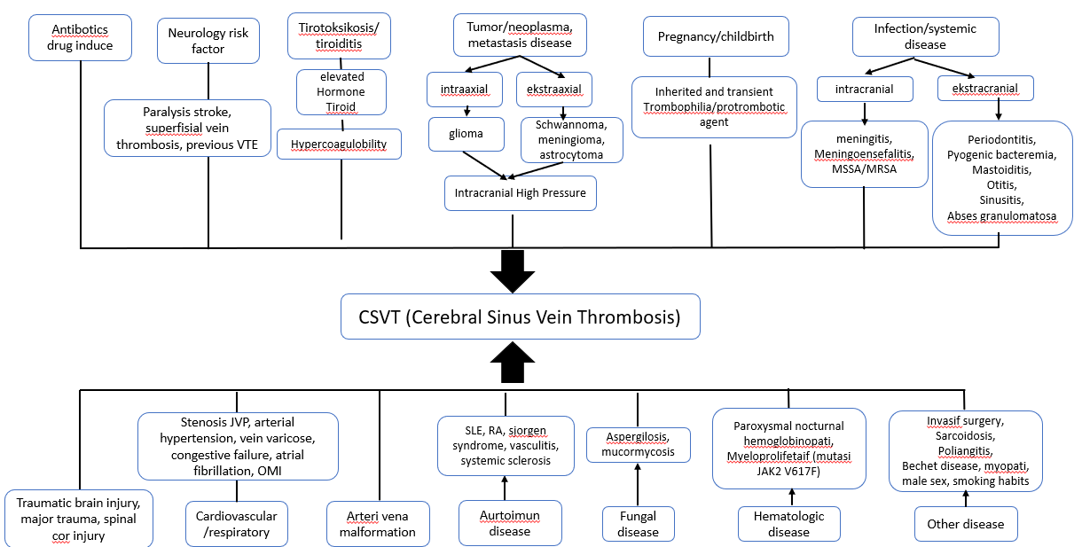

Figure 2. Risk Factors in Cavernous Sinus Vein Thrombosis (CSVT)

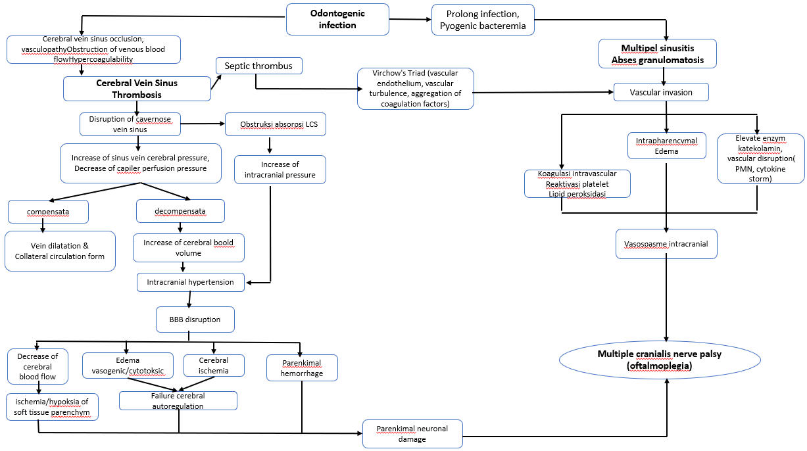

Figure 3. Pathophysiology of Cavernous Sinus Vein Thrombosis (CSVT)

The clinical laboratory findings in the case report are leukocytosis and increased D-dimer enzyme, where D-dimer is a product of fibrin degradation. Elevated D-dimer levels reflect the activation level of the fibrinolysis system and coagulation factors. The primary diagnosis is carried out through MRI and MRA if other imaging modalities fail. DSA is only performed if there is ambiguity in CT-Angiography and MRI/MRA imaging or when endovascular intervention is planned due to the associated risks. CT-Scan and MRI imaging combined with MRA imaging is the preferred method for diagnosis with good sensitivity, used to establish a diagnosis of CSVT as in this case report, where significant results were obtained in determining the area of the cavernous sinus that experienced obstruction and massive expansion was found rather than the predilection for odontogenic infection which caused complications in the patient's neurological deficits. (Saposnik et al., 2024; Ee See Ong et al., 2023; Erratum, 2020; Kashyap et al.m 2019; Pastori et al., 2023, Theologou et al., 2023; Ranjan et al., 2023; Fahrina et al., 2020; Albakr & AlMohish, 2021; Aguiar & Lia Lucas Neto, 2024; Anton-Vazquez et al., 2020)
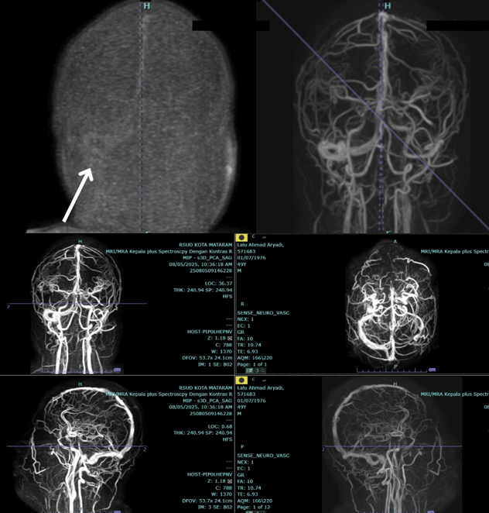
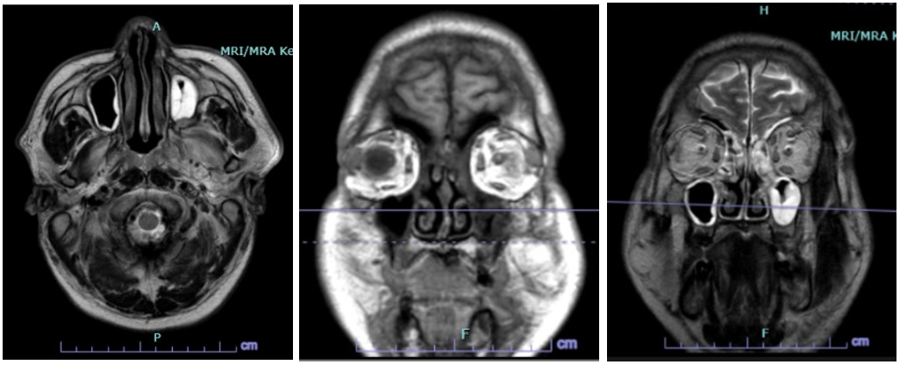
Figure 4. Neuroimaging with MRI and MRA of cavernous sinus vein thrombosis
Figure 5. Advanced imaging with MRI and MRA appear abscess formation due to multiple sinusitis and septic cavernous granulomatous abscess.

The treatment management to the patient in this case report was a third-generation cephalosporin antibiotic that is already broad-spectrum and can penetrate the blood-brain barrier, thereby preventing further massive infection spread and reducing the patient's complaints. Ceftriaxone was administered at a dose of 2 grams every 12 hours for infection control, along with the administration of the steroid dexamethasone to prevent vasogenic edema due to the specific infectious process and to suppress massive inflammation at a dose of 10 mg every 8 hours. Symptomatic supportive therapy, such as citicoline as a neuroprotector, was given at a dose of 500 mg every 12 hours to maintain the stability of the neural basal membrane and prevent ongoing ischemia and neuron cell apoptosis, supported by the administration of atorvastatin 20 mg every 24 hours for its anti-inflammatory effect. Other supportive treatement such as peinloss analgesic at a dose of 3x400mg IV, gastro mucoprotector with a proton pump inhibitor at a dose of 1x40mg IV to support symptomatic complaints in the patient. Administration of anticoagulants with LMWH is the main treatment to prevent the occurrence of cavernous sinus thrombosis. With the management provided above, the patient received care for 3 weeks and experienced a fairly significant change with improvement in symptoms of ophthalmoplegia and headache progression. (Ee See Ong et al., 2023; Erratum, 2020; Cynthia & Immanuel, 2023; Buljan et al., 2019; Albakr & AlMohish, 2021; Umurungi et al., 2024)
The admission of carbonic anhydrase inhibitors such as acetazolamide at a dose of 2x250mg IV is an additional recommendation in management if there are significant symptoms of increased intracranial pressure, as it helps relieve headaches and prevent vision damage. Administration of therapy according to symptoms, such as phenytoin 3x100mg IV as prophylactic antiepileptic therapy in patients with acute seizure symptoms indicating focal neurological deficits due to supratentorial lesions, focal edema, or infarction (ischemic/hemorrhagic), is an additional recommendation in patient treatment management. (Saposnik et al., 2024; Borhani-Haghighi & Hooshmandi, 2024; Kashyap et al., 2019; Theologou et al., 2023; Asfaw et al., 2023; Aguiar & Lia Nucas Neto, 2024; Umurungi et al., 2024)

Conclusion

Cavernous sinus vein thrombosis (CSVT) with a case report in a man with focal neurological deficits caused by a long-standing untreated dental infection since childhood and a history of long-term smoking since middle school. This case report presents a rare case of multiple cranial nerve paralysis as a characteristic clinical manifestation of cavernous sinus vein thrombosis (CSVT) symptoms. This case report emphasizes the importance of considering a CSVT diagnosis through adequate neuroimaging support, as well as monitoring with management using a combination of anticoagulants and broad-spectrum antibiotics, which provides positive implications for the recovery progress in the patient described in this case report.

Acknowledgements

We thank all contributors who participated in our survey for creating this case report. Hopefully, this will help optimize for scientific progress development about rare cases of Multiple Cranialis Nerves Palsies called ophtalmoplegia due to rare infark of vein as sinus cavernosus syndrome called cerebral sinus vein thrombosis due to septic bilateral cavernous sinus granulomatous abscess and multiple sinusitis caused by of odontogenic prolong infection with long history of smoking spreading pyogenic bacteremia into vascular injury involved.

Consent

Written informed consent was obtained from the patient for publication and any accompanying images.

Ethical Approval

Ethical approval was obtained from hospital ethics commite

Patient Perspective

The patient was grateful for his treatments, which improved his quality of life, although he regretted his negligence in managing the disease.

Funding

This case report did not receive any funding assistance.

Declaration of Competing Interest

All of the authors have no conflict of interest.

References
Aguiar, D., & Lia Lucas Neto. (2024). Advances in cerebral venous thrombosis. Stroke. https://doi.org/10.1161/strokeaha.123.044266
Albakr, A. I., & AlMohish, N. (2021). Cerebral venous sinus thrombosis in inflammatory bowel disease: a review of published case reports. The Permanente Journal, 25(3), 1–1. https://doi.org/10.7812/tpp/21.031
Anton-Vazquez, V., Dru, R., Rich, P., Arias, M., & Macallan, D. (2020). Images of the month: cavernous sinus venous thrombosis secondary to Streptococcus milleri maxillary sinusitis: an unusual cause of diplopia and headache. Clinical Medicine, 20(6), e271–e272. https://doi.org/10.7861/clinmed.2020-0689
Asfaw, Y. A., Huang, H., Taimur, M., Anand, A., Poudel, S., Garg, T., Asfaw, B. A., Abebe, B. M., Akbariromani, H., Lazovic, G., & Cueva, W. (2023). Progressive cerebral venous thrombosis with cranial nerve palsies in an adolescent african girl & associated diagnostic pitfalls: a rare case Report. International Medical Case Reports Journal, Volume 16, 45–51. https://doi.org/10.2147/imcrj.s381748
Borhani-Haghighi, A. & Hooshmandi, E. (2023). Cerebral venous thrombosis: a practical review. Postgraduate Medical Journal, 100(1180), 68–83. https://doi.org/10.1093/postmj/qgad103
Cetin, I, D., Eraslan, C., Simsek, E., Kanmaz, S., Serin, H. M., Yilmaz Karapinar, D., Keskin Yilmaz, S., Aktan, G., Tekgul, H., & Gokben, S. (2021). Cerebral sinovenous thrombosis in children: A single-center experience. Turkish Archives of Pediatrics, 56(3), 236–244. https://doi.org/10.5152/turkarchpediatr.2021.20073
Ciarambino, T., Crispino, P., Minervini, G., & Giordano, M. (2023). Cerebral sinus vein thrombosis and gender: a not entirely casual relationship. Biomedicines, 11(5), 1280. https://doi.org/10.3390/biomedicines11051280
Cynthia, & Immanuel, S. (2023). Thrombosis: A laboratory diagnosis of cerebral sinus venosus thrombosis (csvt) with cardiac myxoma. Endless: international journal of future studies, 6(1), 181–197. https://doi.org/10.54783/endlessjournal.v6i1.136
Delgado, M. G., & Bogousslavsky, (2020). Cerebral hyperperfusion syndrome and related conditions. Eur Neurol, 83 (5): 453–457. https://doi.org/10.1159/000511307
Ee See Ong, D., Meng Hsien, Y., Mohd Khialdin, S., & Wan Abdul Halim, W. H. (2023). Unilateral abducens nerve palsy as the lone sign of cerebral venous sinus thrombosis: a case report and literature review. Cureus. https://doi.org/10.7759/cureus.41350
Fahrina, D., Kemal, M. A. R., Syah, A. A., Melita, M., & Soertidewi, L. (2020). Cerebral sinus venous thrombosis pada penderita systemic lupus erythematosus. Majalah Kedokteran Neurosains Perhimpunan Dokter Spesialis Saraf Indonesia, 36(3). https://doi.org/10.52386/neurona.v36i3.73
Harloff, A., Blazhenets, G., Fostitsch, J., Strecker, C., Dersch, R., Mayerhofer, E., & Meyer, P. T. (2024). Effect of cerebral sinus venous thrombosis and its location on cerebral blood flow: a [15O] water PET study in acute stroke patients compared to healthy volunteers. EJNMMI Research, 14(1). https://doi.org/10.1186/s13550-024-01180-9
Horley, M., Gomathinayagam, K., & Koukkoulli, A. (2024). Mydriasis and ophthalmoplegia in a 10-year-old girl: a diagnostic predicament. Ophthalmology Research: An International Journal, 19(6), 64–67. https://doi.org/10.9734/or/2024/v19i6445
Ilgen Uslu, F. (2015). Painful ophthalmoplegia: a case report and literature review. Ağrı - the Journal of the Turkish Society of Algology. https://doi.org/10.5505/agri.2015.67699
Kashyap, M., Rai, N. K., Singh, R., Joshi, A., Rozatkar, A. R., Kashyap, P. V, Mishra, S., & Mudda, S. (2019). Prevalence of epilepsy and its association with exposure to toxocara canis : a community ‑ based , case – control study from rural Northern India management of benign paroxysmal positional vertigo not attributed to the posterior semicircular canal : a cas. 22(4). https://doi.org/10.4103/aian.AIAN
Kethireddy, N., & Sama, S. (2019). Cerebral sinus venous thrombosis in the setting of acute mastoiditis. Cureus. https://doi.org/10.7759/cureus.4023
Krunoslav Buljan, Gordan Šarić, Hafner, D. C., & Ranjan, R., Gie Ken-Dror, & Sharma, P. (2023). Pathophysiology, diagnosis and management of cerebral venous thrombosis: A comprehensive review. Medicine, 102(48), https://doi.org/10.1097/md.0000000000036366
Medeiros, F. C., Moraes, A. C., Louis, A., Vaz, T., & Flávia Esper Dahy. (2022). Cerebral venous sinus thrombosis presenting with subarachnoid hemorrhage: a series of 11 cases. Acta Neurologica Belgica, 123(3), 911–916. https://doi.org/10.1007/s13760-022-02081-1
Parija, S., Dash, N., & Jeyaraj, G. (2023). Sixth cranial nerve palsy and dense cerebral venous sinus thrombosis in a child with nephrotic syndrome. BMJ Case Reports, 16(6), e254044. https://doi.org/10.1136/bcr-2022-254044
Pastori, D., Cormaci, V. M., Marucci, S., Franchino, G., Del Sole, F., Capozza, A., Fallarino, A., Corso, C., Valeriani, E., Menichelli, D., & Pignatelli, P. (2023). A comprehensive review of risk factors for venous thromboembolism: from epidemiology to pathophysiology. International Journal of Molecular Sciences, 24(4), 3169. https://doi.org/10.3390/ijms24043169
Sahu, M., Sheikh, A., Sahu, K., Mandal, P., Rajput, G. S., Sharma, H., & Sahu, G. K. (2024). A review on ophthalmoplegia through patient case studies: a comparative analysis. Journal of Applied Health Sciences and Medicine. https://doi.org/10.58614/jahsm4112
Saposnik, G., Bushnell, C., Coutinho, J. M., Field, T. S., Furie, K. L., Najibah Galadanci, Kam, W., Kirkham, F. C., McNair, N. D., Singhal, A. B., Thijs, V., & Victor X.D. Yang. (2024). Diagnosis and management of cerebral venous thrombosis: a scientific statement from the american heart association. Stroke, 55(3). https://doi.org/10.1161/str.0000000000000456
‌ Sharma, P., Mehta, M., Garg, R., Rizvi, I., Verma, R., Goel, M., Malhotra, H., Malhotra, K., Kumar, N., Uniyal, R., & Pandey, S. (2020). The multiple cranial nerve palsies: a prospective observational study. Neurology India, 68(3), 630. https://doi.org/10.4103/0028-3886.289003
Shen, X., Morón, F. E., & Gao, B. (2017). Imaging of cerebral venous complications in patients with infections. Radiology of Infectious Diseases, 4(3), 131–135. https://doi.org/10.1016/j.jrid.2017.08.002
Theologou, R., Nteveros, A., Artemiadis, A., & Faropoulos, K. (2023). Rare causes of cerebral venus sinus thrombosis: a systematic review. Life, 13(5), 1178. https://doi.org/10.3390/life13051178
Umurungi, J., Ferrando, F., Cilloni, D., & Sivera, P. (2024). Cerebral vein thrombosis and direct oral anticoagulants: a review. Journal of Clinical Medicine, 13(16), 4730. https://doi.org/10.3390/jcm13164730
Wino, W. V., & Prayitnaningsih, S. (2022). Painful ophthalmoplegia in carotid-cavernous fistula. JPHV (Journal of Pain Vertigo and Headache), 3(1), 1–5. https://doi.org/10.21776/ub.jphv.2022.003.01.1
Yang, G., Zhang, J., Liu, Q., & Chai, E. (2024). A case report of frontal sinus abscess complicated by epidural abscess with a literature review. Infection and Drug Resistance, Volume 17, 4359–4367. https://doi.org/10.2147/idr.s483905

‌

